LAB 1
EDGE INTELLIGENCE
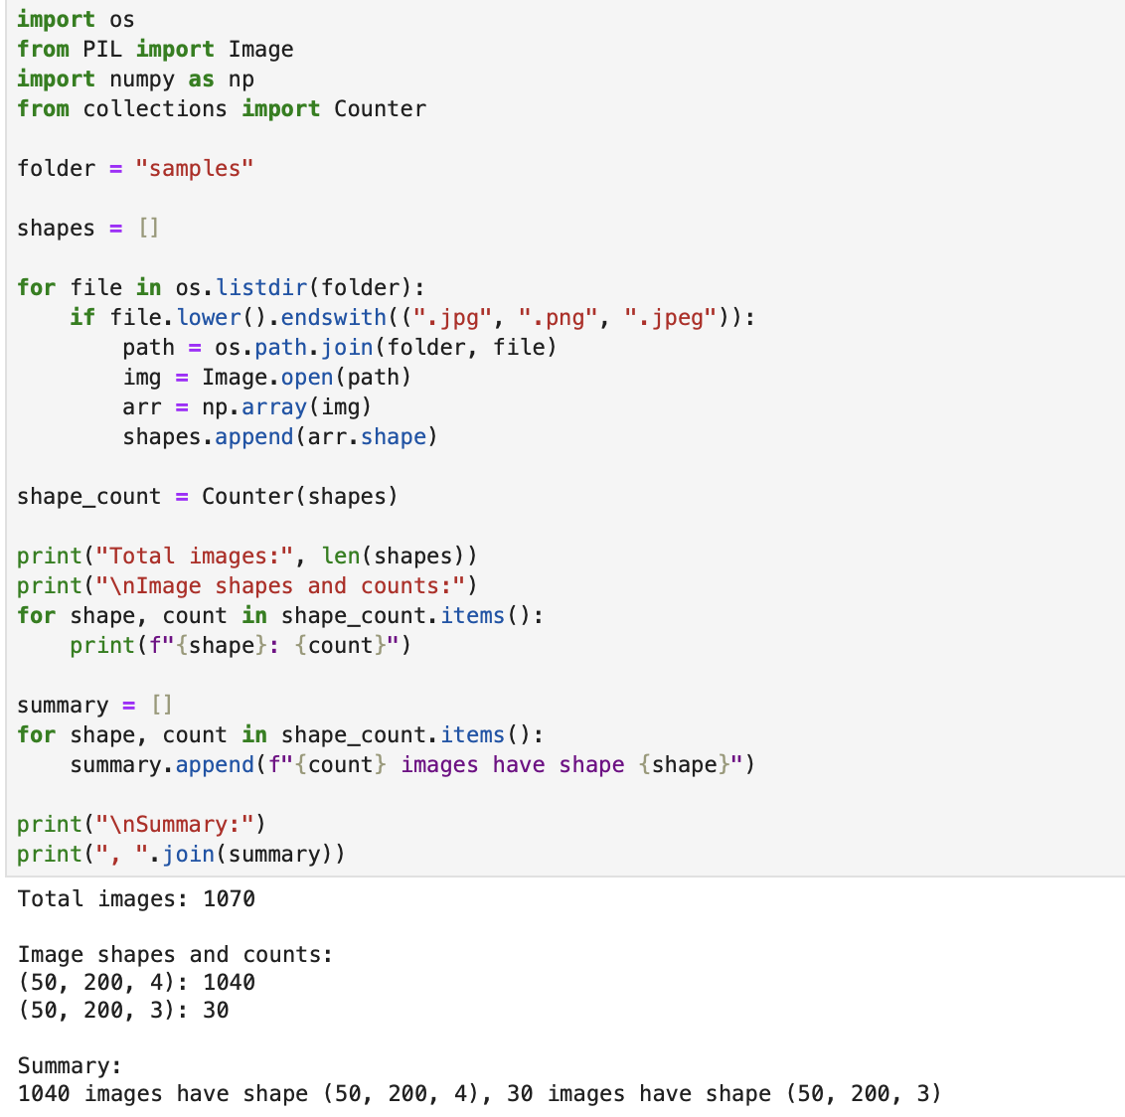

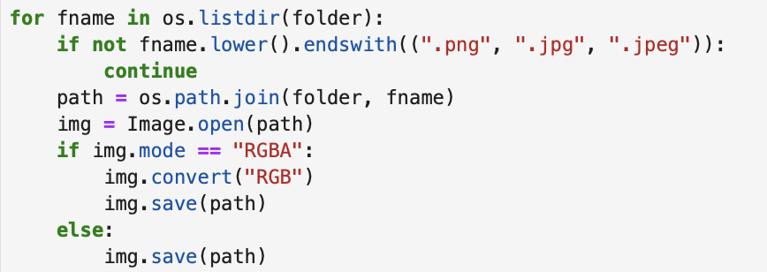
Pillow.Image.convert(mode) does not modify the image in-place. It returns a new Image object. In the script the return value of convert("RGB") is ignored, so the img variable still refers to the original RGBA image. Calling img.save(path) therefore re-saves the original image unchanged. This is a classic “forgot to assign the function result” logical bug.
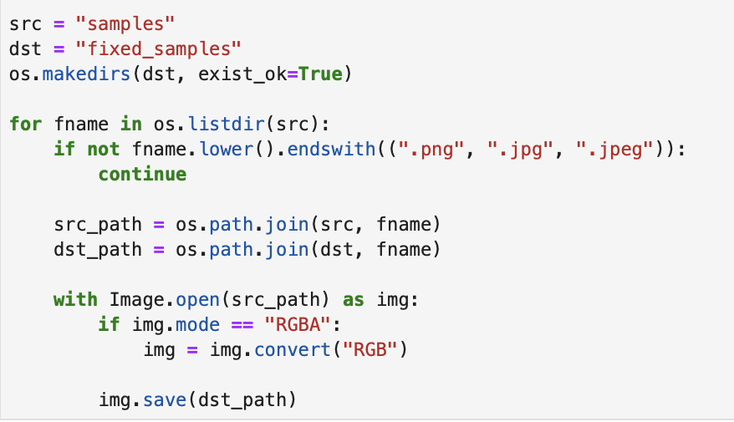
Assign the result of convert() back to img because convert() returns a new object.
Use with Image.open(...) as img: to avoid open file handles and ensure the file is closed before saving (prevents “file in use” errors on some).
Saved the reshaped images into a new file named as fixed_samples.
We verify the shape again by running the first code again. We can see that image sizes has changed from (50,200,4) to (50,200,3).

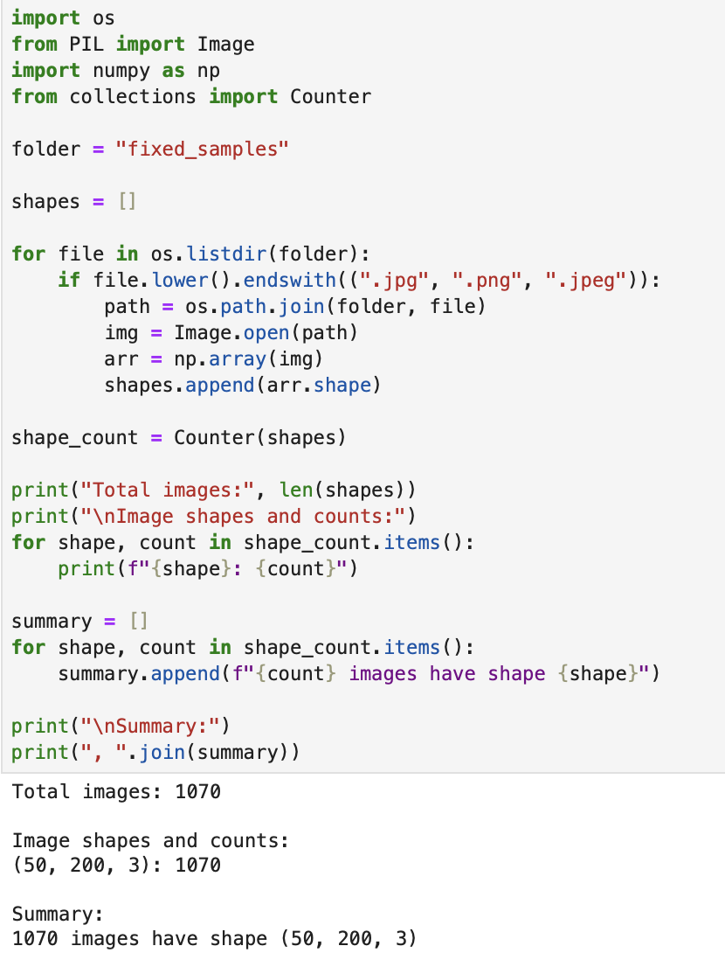
DATASET

